**Team Exercise 6**

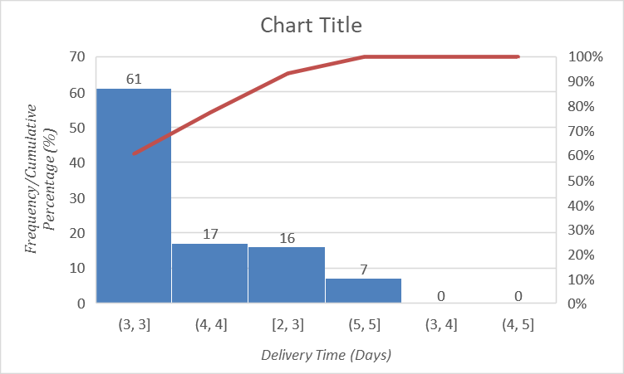



**Interpretation**

It is a cumulative percentage plot, also known as an ogive. It shows the percentage of customers who received their orders within a certain number of days.

**Key features:**

* **Rapid fulfillment for most orders:** Nearly 80% of orders are delivered within 2 days, and over 90% are delivered within 3 days. This suggests that NuCo is efficient at fulfilling most orders quickly.
* **Long tail of slow deliveries:** While most orders arrive quickly, there is a significant minority that take much longer. Only about 95% of orders are delivered within 5 days, and it appears that some orders take much longer than that.
* **Unclear data:** The specific percentages and delivery times are difficult to read due to the scale and quality of the image.
* Missing information: The graph lacks a title, axis labels, and data points, which would make it easier to understand and interpret.